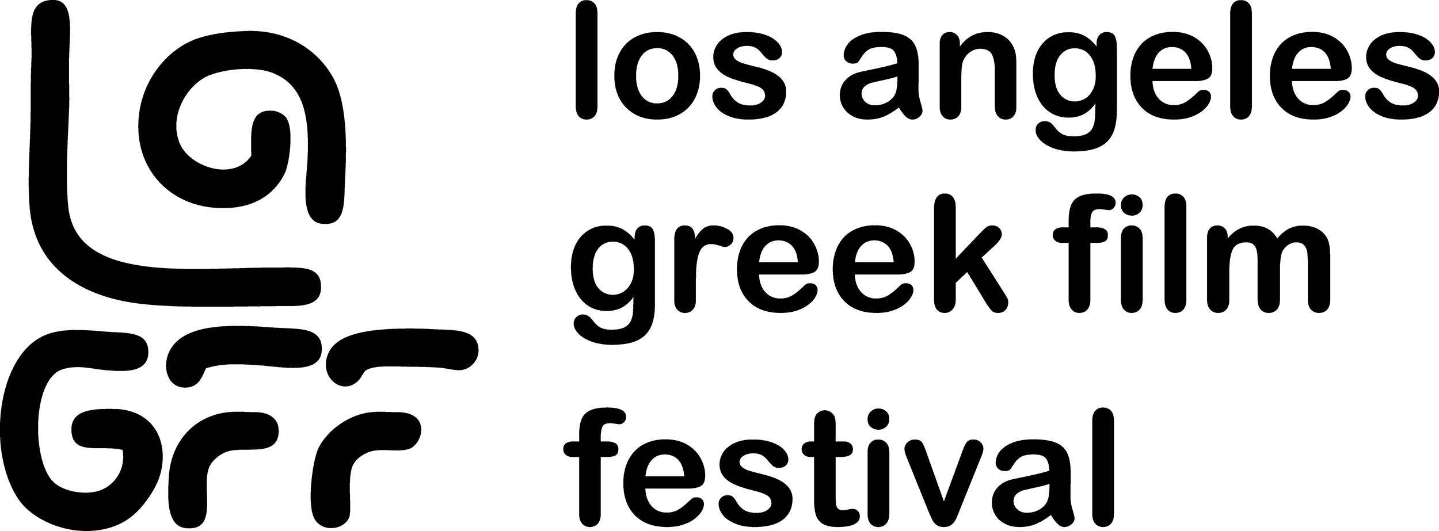

17th Los Angeles Greek Film Festival Announces 2023 Program

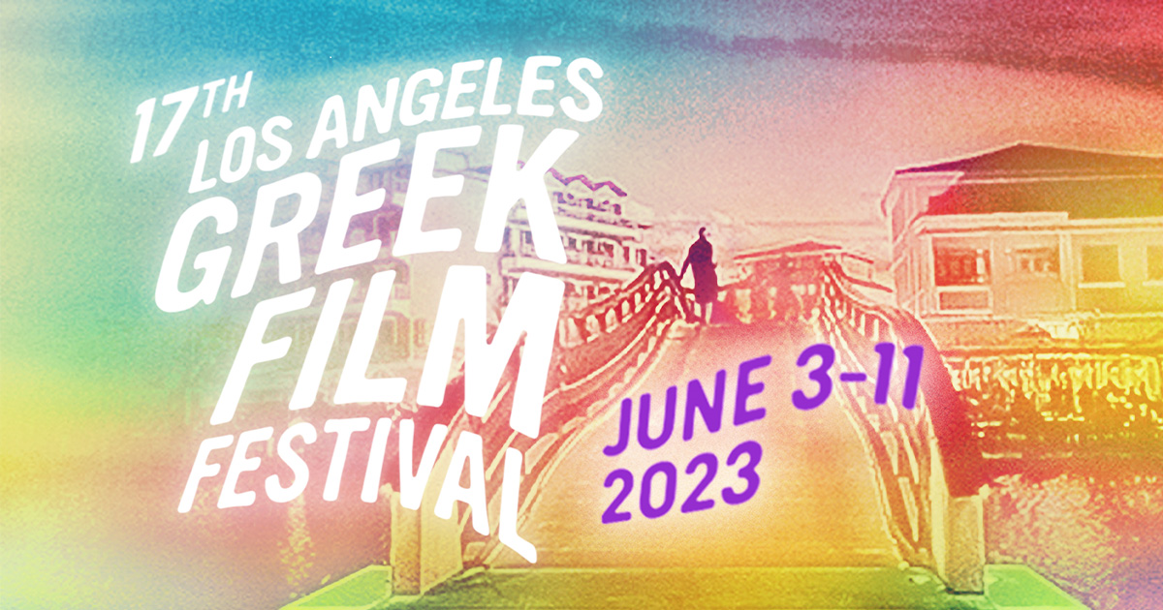

(May 22, 2023, Los Angeles, CA) - Artistic & Festival Director, Aristotle Katopodis has announced an impressive lineup for the 17th Annual Los Angeles Greek Film Festival (LAGFF) beginning June 3 through 11, 2023. LAGFF includes World Premieres, West Coast Premieres, screenings, events, panels, Masterclass and a virtual program of screenings following the Festival. “Over the past 16 years, LAGFF has screened over 580 films and hosted over 530 filmmakers supporting their films,” states Katopodis. “Beyond films and filmmakers, this year we are collaborating with Drama International Short Film Festival, a premiere European Short Film Festival in the program “Drama Comes To Hollywood”, and establishing the first Fellowship of student filmmakers. The first two filmmakers, Mavridou and Arabatzi, with the award-winning short film HUSSIES will be in Los Angeles this June.

Key Dates and Venues
- June 3 Opening Night Reception, Film & George Pelecanos Tribute, hosted by UCLA Stavros Niarchos Foundation Center for the Study of Hellenic Culture, James Bridges Theater
- June 4 George Pelecanos presents a Masterclass hosted by Los Angeles City College for aspiring filmmakers and film students
- June 4-10 Theatrical Screenings & Q & As at Regal LA Live DTLA
- June 8 Hollywood Scene & Be Seen Bash presented by Power Muse + LAGFF
at The House on Sunset
- June 10 Filmmaker Brunch (exclusive) at the Consul General’s Residence
- June 11 Discovery Days auditing (exclusive)
- June 11 Closing Night Film, Orpheus Awards & Gala, Pacific Design Center
- June 12-18 Virtual Screenings
Festival Trailer Here
Information and pricing on the all-access LAGFF Gold Pass HERE
LAGFF Red Carpet Opening Night on June 3rd, kicks off with a Tribute to a Greek-American master who has contributed greatly to American literature and film industry. Novelist, screenwriter, producer, showrunner George Pelecanos will be presented with the 2023 Honorary Orpheus Award by industry executive, director and producer Kary Antholis.


George Pelecanos, photo by Alexa King

A screening of BLACK STONE, a new film by Spiros Jacovides will follow the Tribute. With comedic undertones, the film examines the changing Greek urban society. Director Spiros Jacovides and actor/rapper Kevin Zans Ansong (Black Morris) will be in attendance. The event includes a red-carpet and reception outside the James Bridges Theatre at UCLA, followed by a Tribute and Screening begin. Opening Night LAGFF is sponsored by the UCLA Stavros Niarchos Foundation Center for the Study of Hellenic Culture.

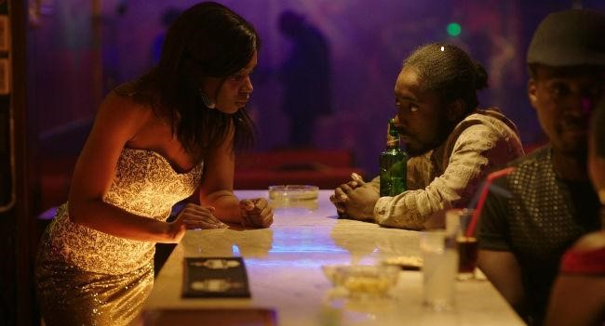
Black Stone, Dir. Spiros Jacovides

The Festival Closing Night gala will be held at the state-of-the-art Silver Screen Theater of the Pacific Design Center and includes a red carpet event, screening of LISTEN with filmmakers and actors in attendance, break with appetizers and drinks, followed by the Orpheus Awards Show and Reception. An inaugural “Patron of the Arts” Orpheus Award will be presented to a member of the LAGFF community.

LISTEN (Ákousé Mé) directed by Maria Douza deals with issues of prejudice against disability and of xenophobia, and how these are countered by the power of pure and unconditional love. Financial upheaval forces a sixteen-year-old deaf girl to leave her progressive Athens school and return to her father’s struggling island, where she is confronted with prejudice and intolerance—including, most shockingly, her own. Lead actors Efthalia Papacosta and Dimitris Kitsos, and director Maria Douza are expected to attend.
Discovery Days will take place June 7-11. Formerly the International Project Discovery Forum
(IPDF), Discovery Days is a Los Angeles pioneer in the promotion of international independent
film development. A four-day lab for films in the stage of development, Discovery Days is the industry hub of the Los Angeles Greek Film Festival. Utilizing the abundant cinematic resources in Los Angeles, the lab bridges two worlds– those of American and European independent cinema.

Los Angeles Greek Film Festival and Global Greek Film Initiative are generously supported by:

GPK & Associates (https://www.gpkassociates.com) and the Kolovos Family — GPK & Associates is an established property management company and family-owned business. GPK & Associates takes a hands-on approach to managing communities and has successfully leased and managed a large portfolio of apartment homes in the greater Los Angeles area for over 40 years. It is the company's mission to provide residents with the highest quality customer service and ensure their homes are comfortable and the properties are well maintained. GPK & Associates takes pride in their level of customer service and quality of workmanship provided in their remodeled apartment homes. They believe this translates into a positive rental experience for all residents who live in their communities.
California Arts Council (https://arts.ca.gov) — Established by the State of California in 1976, the California Arts Council (CAC) is a state agency with a mission of strengthening arts, culture, and creative expression as the tools to cultivate a better California for all. CAC is California’s only public arts grants provider with funding that is accessible to all 58 counties. As a state agency, CAC supports local arts infrastructure and programming statewide through grants, programs, and services. The arts sector is large and diverse, and its businesses and workforce are a significant contributor to the state economy and identity. California is home to 11,563 nonprofit arts organizations and the state’s creative sector accounts for $18.67 billion in assets and 15.4% of California’s total employment.

Los Angeles County Department of Arts & Culture (https://www.lacountyarts.org) — The mission of the Los Angeles County Department of Arts and Culture (LACDAC) is to advance arts, culture, and creativity throughout LA County. LACDAC provides leadership, services, and support in areas including grants and technical assistance for nonprofit organizations, countywide arts education initiatives, commissioning and care for civic art collections, research and evaluation, access to creative pathways, professional development, free community programs, and cross sector creative strategies that address civic issues. All of this work is framed by the longstanding commitment to fostering access to the arts, and the County’s Cultural Equity and Inclusion Initiative.

The Hellenic Initiative (https://www.thehellenicinitiative.org) — The Hellenic Initiative (THI) is a global nonprofit organization that brings together Diaspora Greeks and Philhellenes to invest in the future of Greece through programs focused on crisis relief, entrepreneurship, and economic development. THI was founded in 2012 by members of the global Greek and philhellene communities who were compelled to respond to the worsening economic crisis and inspired to help shape Greece’s long-term recovery.

European Languages & Movies in America (https://www.elma.org/copy-of-home-1) — The European Languages & Movies in America (ELMA) mission is to create new avenues for better cultural understanding between the people of Europe and the USA by celebrating alternative cinema. Since its inception in 2007, ELMA has supported over 100 events in 30 countries in over 20 languages. ELMA strives to provide more opportunities to view European films by supporting educational and nonprofit venues showing such movies. ELMA supports a wide spectrum of projects, from classic films to the works of emerging talent in order to provide new audiences with an alternative to Hollywood.

Other donors include: Department of Cultural Affairs City of Los Angeles, Hollywood Foreign Press Association, Elios Charitable Foundation, UCLA Stavros Niarchos Foundation Center for the Study of Hellenic Culture, Greek Film Centre, Greek National Tourism Organization, AT&T, Paris Kassidokostas-Latsis, West Coast Investors, R&V Management, Gibson Dunn, Theane Evangelis & James Kousoulas, and Jim Gianopulos.

The Festival is held under the auspices of the General Secretariat for Greeks Abroad and Public Diplomacy of the Greek Ministry of Foreign Affairs and the Consulate General of Greece in Los Angeles.

We are grateful to Honorable Andreas Kyprianides, Consul General of Cyprus, for his continued support and tireless efforts to promote Hellenic and Cypriot issues and interests in Los Angeles.

ABOUT: LAGFF is a 501(c)(3) nonprofit organization that focuses it’s attention to bringing films and filmmakers from Greece, Cyprus, and the rest of the world to the United States. LAGFF will run June 3-11, 2023. For more information, visit www.lagff.org

ABOUT: Global Greek Film Initiative is strategically designed to establish an array of new annual programs to promote cultural exchange between Greece, the US and the Hellenic Diaspora, service opportunities for employment and economic growth within Greece and to be the North American hub and global one-stop collective for Greek film programs and initiatives.
LAGFF 2023 Poster art created by Jonny Hall. Photograph by Georgia Tripodes.

LAGFF 2023 Trailer created by Joel Garber & Araceli Lemos; original Music by Miles Garber; Creative Commons Audio - "Melting Glacier" by EgilSG (altered).

MEDIA CONTACT: Melinda Manos (310) 272-4225, (424) 777-0548
melinda@manospr.com
